Name of Your Company
VERPART SOLUTIONS

Project Title
Advertisement Posting Management on Campus

Team
- Sergio Aupart (MySQL Expert)
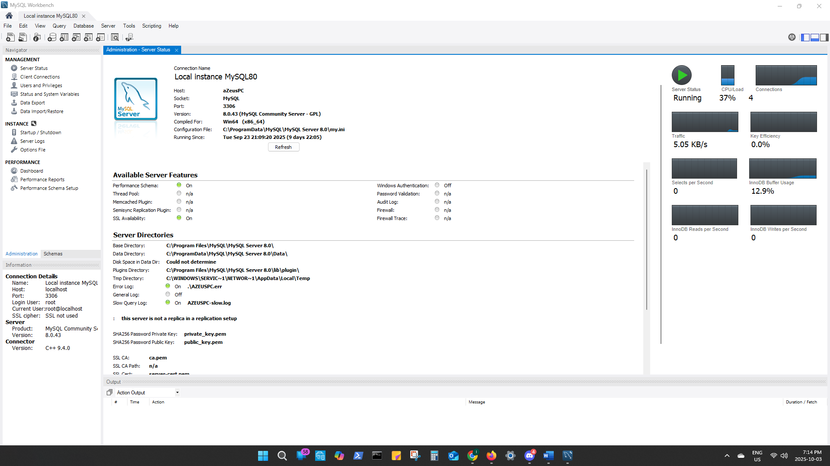

- Mike Verwer (MS SQL Server Expert)
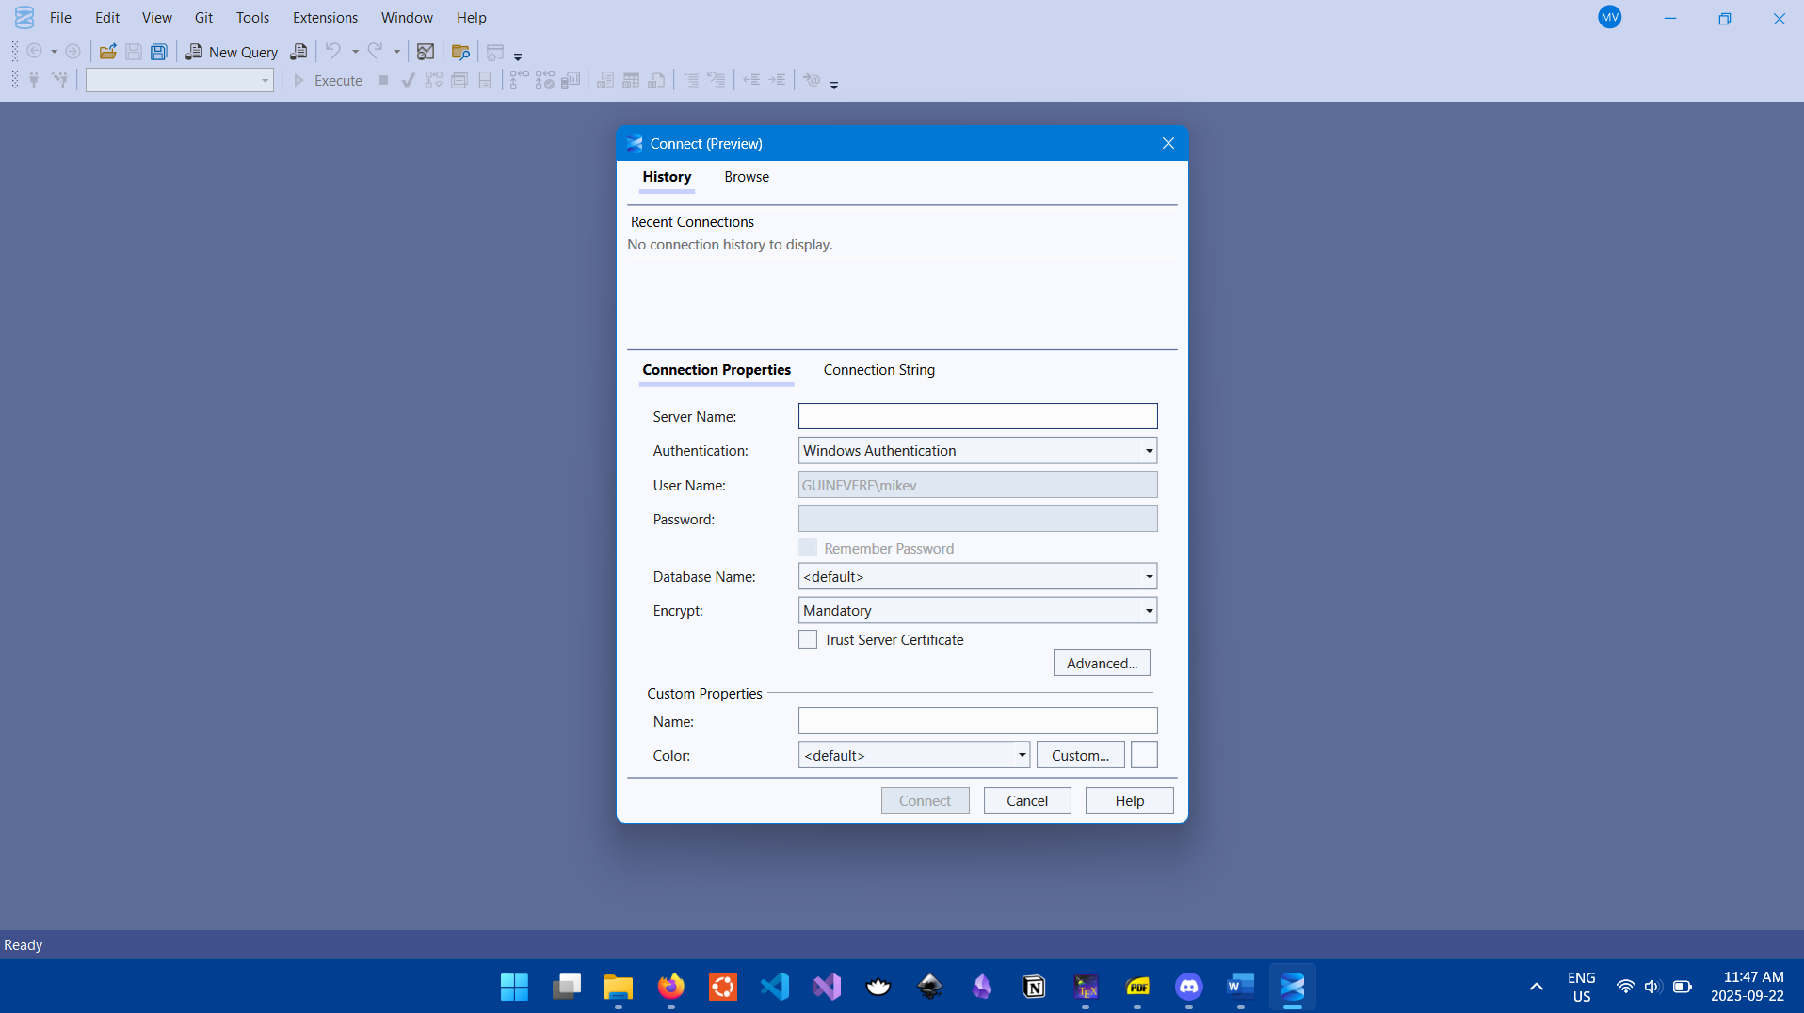

Weekly Meeting Hours
Every Friday 2:00PM – 3:00PM.
If canceled, it will be rescheduled to the following day Saturday, at 2:00PM – 3:00PM. Meetings can be on campus or online, depending on availability.

Project Description

We will build a database to manage advertisement postings on campus boards. Professors, staff members, students, and registered non-college members can post advertisements for topics such as tutoring, room rentals, items for sale, event listings, etc. Each ad is identified by a unique adID, title, post-date, duration, and size (width and height). Ads are placed on specific boards, which are identified by a boardID and described by building, floor, location, and size dimensions. (Sergio)

- A college member is identified by a college ID number and is described by a name, phone number, email address, affiliated department. Specific members have extra attributes. For example, students have a major field of study, while staff and instructors do not have such an attribute. Staff and instructors have an office location and start date of employment. Staff have the attribute position title, while professors do not have this attribute.
  - We assume that all college members are automatically entered into the database. (Mike)
  - We will need a key attribute for non-college members. (Mike)

- Advertisements are defined by a unique adID number, type (ad for private tutorship, rent a room, selling something, looking for a roommate, event advertisement), postdate, duration, size dimensions (width, height) and approval status (Pending/Approved/Rejected).
  - We will need to ensure that there is sufficient capacity on a board to accommodate the ad. (Mike)
  - Board size will be stored as width_mm and height_mm, and constraints can be applied later to ensure that ads cannot exceed available board capacity. (Sergio)

- People can send messages to the person who posted the advertisement. These communications (sender name, receiver name, message, date, time, regarding post (post number and post title)) are also stored in the database.

- All advertisements must be approved by the person responsible (we store information of this person).
  - We will need to create an entity (or attribute of a person) to designate them as an ad Reviewer. (Mike)
  - Only Employees can be Reviewers. (Sergio)
  - A Reviewer cannot approve their own Ad. (Sergio)

- Board location on campus is identified by a board ID and described by building, floor, and location on the floor.
  - We will also need to know the size of the board. (Mike)

There is a hierarchy of Persons here. Eg: A faculty is a Person who is a College Member who is an Employee who is a Faculty
Ie. Faculty = Person -> College Member -> Employee -> Faculty
There are two ways of representing this in the E-R diagram/database
- Simple Approach
Create one Person entity and include all possible attributes that any type of person may have. Attribute values will simply be NULL if the attributes don’t apply to the instance of Person. For example, a non-college member would be represented as:
Person(
ID=X, Name=[name], Phone=###, email=abc@mail.com, college_ID=NULL, Department=NULL, Major=NULL,
Office_Location=NULL, Employment_Start_Date=NULL, Position_Title=NULL );

Very easy to implement but creates a table with many NULL entries. Additionally, makes querying for specific types of Persons more difficult.

- Supertype and Subtype Approach
Create a supertype Person entity which has subtypes College Member and Non-Member. College Member has subtypes Student and Employee. Employee has subtypes Staff and Faculty.
This creates a cascading binary tree of entities that are each connected by an IS-A relationship as pictured below. Where the Key attribute for all Person types is the Person_ID. Note that Non-Members and Faculty do not have any new attributes or relationships and so they do not need their own subclass.

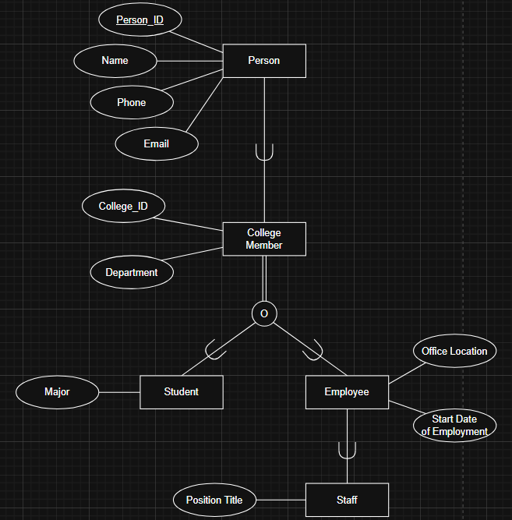

Assumptions about Cardinality and Participations
You can write all the assumptions about Cardinality and Participations (total/partial) here.
Mike/Sergio
- A Board can have many Ads and may have none.
- Only Ads that get approved may be posted to a Board.
- An approved Ad can be placed on multiple Boards but must be placed on at least one Board.
  - Approval status is an attribute of the APPROVAL relationship, and since an Ad may or may not be approved, the participation between Ad and Board through the POSTS relationship is partial on both sides.
- A Person can submit many Ads, but may not submit any.
- Each Ad is submitted by exactly one Person.
- A Message has exactly one sender and exactly one recipient.
- A Person may send and receive multiple Messages.
- Each Ad must be approved by exactly one Reviewer (Employee).
- A Reviewer (Employee) can approve many Ads, or none.
- All College Members are automatically included in the system. Non-Members must be manually registered.
- Every College Member is either a Student or an Employee.
- It is possible for a Student to also be Employee.
- Not all Employees are Staff.

EER Modeling Diagram

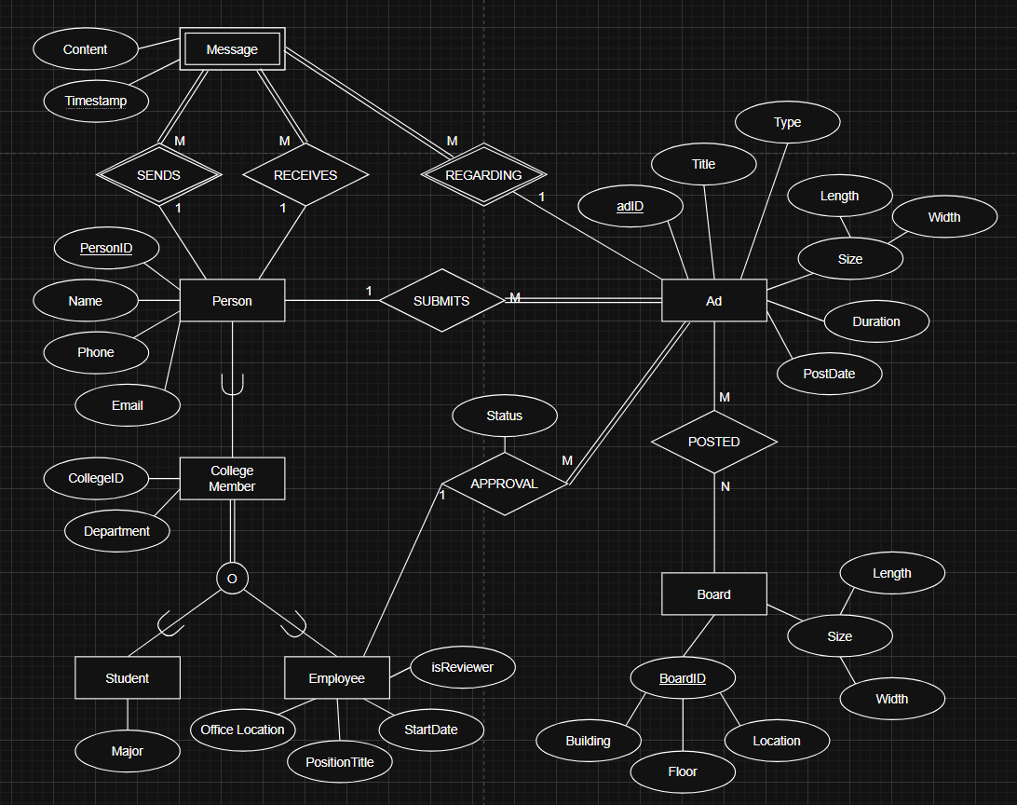

ER-Model Mapping to Database Relational Schema
Given the following two facts about the Employee subclasses:
- Only the Staff subclass has any additional attributes, i.e. Professors have no attributes that Employees do not have.
- The only extra attribute that Staff have is PositionTitle.
We opt for the mapping method of using a Type attribute to specify the subclass, where the Type attribute in this case is just PositionTitle itself, and Professors have the PositionTitle of ‘Professor’. In this case, all Staff could be selected by using a SELECT query for the Employee table where PositionTitle is not professor.

Person(PersonID, Name, Phone, Email)
CollegeMember(PersonID, CollegeID, Department)
Student(PersonID, Major)
Employee(PersonID, OfficeLocation, StartDate, PositionTitle, isReviewer)
Ad(adID, PosterID, ReviewerID, Title, Type, Length, Width, Duration, PostDate, Status)
Board(Building, Floor, Location, Length, Width)
Ad_Posted_Board(adID, BoardID)
Message_Ad_Sender_Recipient(SenderID, adID, Timestamp, RecipientID, Content)

Normalization
- The Person(…) relation is in BCNF since PersonID is an atomic primary key. We assume that each person has one phone number and one email address, and no two people have the same phone number or email. Therefore, Phone and Email are candidate keys. Hence, even though Phone → A, where A ⊆ {PersonID, Name, Email} and Email → B, where B ⊆ {PersonID, Name, Phone}, these functional dependencies do not break BCNF.
- Similarly, CollegeMember(…) is also in BCNF because CollegeID is a candidate key.
- Student(…) is trivially in BCNF.
- Employee(…) is in BCNF since there are no functional dependencies between non-prime attributes and
PersonID → OfficeLocation, StartDate, PositionTitle, and isReviewer.
If OfficeLocation were unique among all employees, it would then be a candidate key. So even though OfficeLocation → PersonID, etc. in this case, it would still not violate BCNF.
- Ad(…) is also in BCNF since adID is the only candidate key and there are no functional dependencies between any of the non-prime attributes. Note that since a person can post many ads, PersonID ↛ AdID.
- Board(…) is in BCNF since nothing is functionally dependent on Length or Width, and (Building, Floor, Location) is a minimal superkey.
Note: Location refers to location on the floor, so it is not a candidate key on its own.
- Ad_Posted_Board(…) is in BCNF since (AdID, BoardID) is a minimal superkey because of the many-to-many relationship between Ad and Board.
- Message_Ad_Sender_Recipient(…) since {SenderID, adID, Timestamp} → (RecipientID, Content), and {SenderID, adID, Timestamp} is a minimal superkey. There are no other functional dependencies.

Determining Data Types (Domain) and Constraints
Data Types and Constraints per Table:

Person:
- PersonID – Auto incrementing integer: Sensible choice for a non-descriptive primary key
- FirstName – VARCHAR(20) NOT NULL: Each person should have a full name
- LastName – VARCHAR(20) NOT NULL: Each person should have a full name
- Phone – VARCHAR(20): 20 characters to accommodate for international phone numbers
- Email – VARCHAR(25) UNIQUE NOT NULL: an email address is required to send messages between people and each email needs to be unique to prevent ambiguity.

CollegeMember:
- PersonID – INT PRIMARY KEY: Must be INT since it is the foreign key to the Person parent table
- CollegeID – CHAR(9) UNIQUE NOT NULL: All college members need a unique college ID that must be 9 characters for uniformity and data integrity.
- Department – VARCHAR(60) NOT NULL: All college members must be affiliated with a department.

Student:
- PersonID – INT PRIMARY KEY: Must be INT since it is the foreign key to the Person parent table
- Major – VARCHAR(60): Allowed to be NULL since some students may not have yet declared a major.

Employee:
- PersonID – INT PRIMARY KEY: Must be INT since it is the foreign key to the Person parent table
- OfficeLocation – VARCHAR(10): Encoded as Building Acronym, Floor, Room number. Allowed to be NULL and non-unique since some people may not have on office, or share an office
- StartDate – DATE NOT NULL: If an employee was hired, they must have a start date. Defaults to CURRENT_DATE.
- PositionTitle – VARCHAR: Allowed to be NULL. For data integrity, if must take on a value in:
{ 'Faculty', 'Administration', 'Staff', 'Support', 'Specialized', NULL }
- IsReviewer – BIT: Use BIT instead of BOOLEAN for cross-platform support as MS SQL Server does not support BOOLEAN datatype. Defaults to 0 (ie. False).

Board:
- Building – CHAR(3): Every building is encoded as a 3 character acronym. Part of a composite key, so brevity is required.
- BldgFloor – INT: Obvious. Part of a composite key
- Place – CHAR(1): Despite the name, refers to an enumeration of the ad-boards on a given floor of a given building, enumerated with capital letters.
- BoardWidth – INT NOT NULL: Measurement is recorded in cm so decimal precision is not required. NOT NULL since it is required information in order to check if a board has space for an ad.
- BoardLength – INT NOT NULL: Measurement is recorded in cm so decimal precision is not required. NOT NULL since it is required information in order to check if a board has space for an ad.

Ad:
- PosterID – INT NOT NULL: An Ad must be posted/requested by a person, refers to Person table.
- ReviewerID – INT: Allowed to be NULL since it may not be reviewed by anyone yet.
- AdID – INT Auto-Increment: Sensible choice for a non-descriptive primary key
- Title – VARCHAR(100) NOT NULL: An add requires a descriptive but brief title.
- AdType – VARCHAR(20) NOT NULL: Every ad must belong to category. For data integrity and effective querying, limited to values if:
{ 'Tutorship', 'Rent', 'Sale', 'Roommate', 'Event' }
- AdWidth – INT NOT NULL: Measurement is recorded in cm so decimal precision is not required. NOT NULL since it is required information in order to check if a board has space for an ad.
- AdLength – INT NOT NULL: Measurement is recorded in cm so decimal precision is not required. NOT NULL since it is required information in order to check if a board has space for an ad.
- Duration – INT: Measured in number of days. Allowed to be NULL since poster may not have a preference.
- AdStatus – VARCHAR(10): Allowed to be NULL since NULL is interpreted as ‘Pending’. For effective querying and data integrity, restricted to the following values:
{ 'Pending','Approved','Rejected' }

Ad_Posted_Board:
- All 4 columns of this table are primary keys and foreign keys, so they take on their respective data types

Messages:
- TimeLogges – TIMESTAMP: Part of a composite key, requires highest precision possible to ensure unique composite key constraint
- SenderID – INT: Part of a composite key, refers to Person table.
- AdID – INT: Part of a composite key, refers to Ad table.
- RecipientID – INT NOT NULL: Refers to Person table, must not be NULL since every message needs a recipient.
- Content – TEXT/VARCHAR(MAX): The MySQL version uses TEXT and the MS SQL version uses VARCHAR(MAX) because of syntactic differences. Allowed to be NULL for practicality.

Creating Database and Tables - SQL DDL
You do not need to copy SQL commands here. Save your SQL commands in a script file and just mention the name of the file here. Make sure the script file is stored besides this document within the same folder.
MySQL Version – MySQL-CREATE.sql
MS SQL Server Version – MSSQL-CREATE.sql

Inserting Values in Tables
You do not need to copy SQL commands here. Save your SQL commands in a script file and just mention the name of the file here. Make sure the script file is stored beside this document within the same folder.
MySQL Version – MySQL-INSERT.sql
MS SQL Server Version – MSSQL-INSERT.sql

SQL Queries
MS SQL Server queries are stored in MSSQL_Querries.txt
MySQL queries are stored in MySQL_Queries.txt

Views
MS SQL Server views are stored in MSSQL_Querries.txt
MySQL views are stored in MySQL_Queries.txt

